PERFORMANCE EVALUATION OF QoS IN DYNAMIC RAN SLICING OF 5G NETWORK

Parikshit P Hegde

Assistant Professor

Computer Science Department

KLE Technological University Hubballi, India

[parikshit@kletech.ac.in](mailto:parikshit@kletech.ac.in)

Lavanya Shahapur

Student

Computer Science Department

KLE Technological University Hubballi, India

[shahapurlavanya@gmail.com](mailto:shahapurlavanya@gmail.com)

B Ajay Kushal

Student

Computer Science Department

KLE Technological University Hubballi, India

[bajaykushal009@gmail.com](mailto:bajaykushal009@gmail.com)

Pragathi Pujari

Student

Computer Science Department

KLE Technological University Hubballi, India

[pragathipujari06@gmail.com](mailto:pragathipujari06@gmail.com)

Dr. Meena S.M

Professor and Head

Computer Science Department

KLE Technological University Hubballi, India

[msm@kletech.ac.in](mailto:msm@kletech.ac.in)

Kushagra Tomar

Student

Computer Science Department

KLE Technological University Hubballi, India

[kushagratomar2016@gmail.com](mailto:kushagratomar2016@gmail.com)

Ashwini R Jannu

Student

Computer Science Department

KLE Technological University Hubballi, India

[ashwinirjannu@gmail.com](mailto:ashwinirjannu@gmail.com)

***Abstract—Access to the internet is growing exponentially due to its ease of usability, flexibility, and lowering data plans. The diverse network service requirements encourage mobile operators to look for mechanisms that facilitate efficient use of network infrastructure, so that it can reduce the operational and expenditure costs. Use cases like the video streaming services requires high bandwidth, autonomous driving and remote medical surgery requires low latency, and various IoT applications work with low bandwidth to cater to the users needs. We simulate the RAN slicing using an emulator called eXP-RAN which effectively manages the allocation of different network resources to the created slices. The infrastructure, slicing, and service layers are the three distinct layers in the proposed system architecture. The isolation and abstraction of the network resources is also applied to the created slices by this emulator.***

***Keywords—network slicing, ran slicing, eXP-RAN emulator, radio resource, mobile network operator, forwarding nodes, base stations, MEC hosts., video streaming services***

# introduction

The heterogeneous requirements of internet users have posed a challenge to the network service providers in meeting the quality of service parameters(QoS) [11]. The different use cases like video streaming, online gaming, remote surgery, and augmented and virtual reality have different resource and network and requirements. The popularity of internet access through wireless infrastructures makes network operators build on the Radio Access Network (RAN). Compared to 4G, 5G provides extremely low latency capability and twenty times faster peak speed. The autonomous driving requires reliable and low-latency communications. The remote robotic surgery in medical field requires machine-to-machine(M2M) communication. The immersive online gaming requires high mobile broadband for data transfer between the applications. These diverse applications make the available infrastructure insufficient.

Thus Network Slicing comes to an aid to optimally utilize the infrastructure. RAN allows to connect various user equipment (UE) to the core network. The network contains forwading nodes, base stations and radio network controllers which take signal input from UE, process it and sends to the core network. RAN's key benefits are its UE-centric, beamforming MM-Waves, small cells, multipoint and coordinated transmission[21]. MM-Waves have a band spectrum with the wavelength in the range 30GHz to 300GHz. The small cells coverage in a range 10m to few kms, and operate in licensed or unlicensed spectrum with low power radio nodes[19]. The benefits of RAN are its agility, flexibility, cost reduction, and real-time responsiveness. RAN slicing enables forming of multiple logical networks that satisfy various user requirements over the common physical infrastructure[29].

RAN slicing is a solution for the growing network traffic needs and enables a reduction in cost, and improves capacity that minimizes operational expenditure(OPEX)[37]. It provides isolation between network slices and optimizes resource utilization. RAN slicing helps create network slices that enables mobile network operators (MNO) to ensure bandwidth guarantee to the enterprise networks[7]. The radio resources are managed by the RAN, composed of radio and processing units. The Radio unit aids in data transmission or reception in the presence of a transceiver antenna. The processing unit performs precoding, resource-sharing encryption, and radio management.

A major transformation is observed in the telecommunication sector with the evolving 5G networks[27] in data rate. Trillions of sensors and network devices connect intelligently to the core network based on the compute and delay sensitivity needs in 5G networks.

# related work

In [9] the method used for ran slicing is toward operator-to-waveform 5G RAN slicing. It is used to control a maximum number of users and MNO's selection of base station the architecture used for this operator-to-waveform method is three tiers ran slicing framework. The author's main objective in using this method is to improve signal interference and noise ratio (SINR) by up to 120 percent compared to other approaches and to provide waveform-level scheduling of resource blocks to a maximum number of users. The simulation results show that RAN slicing leads to 95 percent of available Base Stations performing 5G transmission technologies which allows for fulfilling the required objective.

RAN should be able to support the following efficient traffic management mechanism, minimizing of inter-slice effects, efficient management of infrastructure, and maximizing the utilization of RAN resources[3]. The radio resources can be shared in two types, dedicated and dynamic manner. The above requirements will impact protocol architecture, the design of Network Functions(NFs), and network management. To achieve the protocol architecture, selection of NFs per slice, slice awareness for QoS framework[26], and slice-tailored NFs optimization must be supported by RAN architecture. The radio NFs are impacted due to inefficient use of radio and transport network resources and inadequate sharing of RAN resources among different slices[23]. Radio NFs of one slice is dependent on another slice. The network management is impacted due to performance monitoring and sharing of HW/SW platforms. To achieve maximum efficiency, one slice should be able to utilize the full bandwidth if the other slices are traffic free[13].

Evaluation of virtualized RAN(vRAN) experimentally using passive optical network(PON) in Fronthaul, which reduces network costs. 5G has enabled internet connectivity and connection of multiple devices through IoT. C-RAN which is a centralized cloud computing-based architecture[38] for RAN which allows supports to 2G, 3G, and 4G, and in the present generation, it will support 5G wireless communications. Some of the available 5G Core(5GC) Network slicing approaches are: 1) Static slicing approach - Network slicing gives dimension to physical networks, which can be used as few physical resources whenever new user requests for resources, thus its will query network providers for requirements[22]. Thus physical resources can be checked, which is equal to the process of solving virtual network mapping problems. 2) Dynamic slicing approach - Network slicing is performed dynamically based on user requirements[30]. The user requirements could vary regarding bandwidth or network functions such as load balancing and firewall services. The benefit compared to static slicing is the resources are allocated on demand by the user at that instance of time. RAN achieves huge flexibility and scalability through a model architecture by using SDN and NFV, which can create multiple slices for different service types such as eMBB, uRLLC, and Mmtc[31]-[33]. Evaluation of bandwidth usage in midhaul, the effect of its delay, latency, and isolation across slices, concludes that slices have specific benefits[32] for all types of services, which can create services in common infrastructure with variations[37].

Network slicing uses a slice configuration algorithm to balance the load of all slices in 5G and 5G RAN[8][13]. The present scenario of network slicing imposes restrictions on resource optimization techniques in RAN, which can heavily load the slices affecting the QoS of telecasting services[28].The weights of nodes present in the topology are poorer than the nodes with uniform structure but have a good rate of performance which indicates that the system can increase its resource utilization rate[30]. The goal of 5G RAN network slicing is to reduce the dimension of the network such that it can be allocated within a few physical networks.

The authors in [4][17] present dynamic network slicing using Software Defined Network(SDN). The customized network service is provided using the Ryu Controller with an example of an electronic Fence application. The network slices are formed dynamically based on the type of application. The network slices are created and adapted according to the service requirement of the user. The resource configuration is adjusted dynamically as the user demand change. The virtual network resources are formed dynamically by applying the network slicing algorithm at the controller using the underlying physical infrastructure. The anomaly detection application is taken to demonstrate network slicing where high bandwidth is allocated when an abnormal event is detected,

In [24], authors proposed a radio resource partitioning algorithm for satisfying the pre-service requirements. The three requirements taken for slicing are resource type, abstraction, and structure. The resource type is taken in the form of the data rate requirement of the user. In resource abstraction, the mapping of the requested resource to the underlying physical infrastructure is performed. The differentiation is provided during resource allocation based on whether it is a downlink or uplink service. The five different prioritization of slices is performed, namely optimal, random, greedy, granularity, and combined granularity-greedy algorithms.

In [23], it discusses the challenges faced by mobile operators in 5G networks. The challenge is defining a slice that contains both the user information and individual service needs. Spectrum sharing, tiling, puncturing, and slice mapping are the concepts used for scheduling network resources. Based on the service latency requirements, the differentiation is provided by the slice manager. The challenges in network resource slicing are, achieving fair allocation of resources, prioritization, and resource reservation. Over-provisioning needs to be eliminated in case of resource reservation to satisfy the user Service Level Agreements(SLAs).

# required tools and software

These are few necessary requirements that needs to be considered for the tool to function. These requirements are as,

*Monitoring of services* - slicing of network needs to be monitored by the tool and should look after the security aspects[14] of slicing the networks which is a unique task of monitoring each of the independent slices. *Service Representation* - Services offered to applications are to be maintained and managed by the service providers provided by the tool. *Network Modeling* - Deployment of all issues such as fronthaul, midhaul, backhaul on the common infrastructure, and virtual network is provided by network modeling. *Adaptability and Reusability* - Services must be reusable and clearly understood by the new users for making the system more efficient. *Service Reconfigurability* - Implementation of services on a virtual network should have the ability to modify the resources for system modules. *Computation Modeling* - The system requires the processing of applications near the data source and destination. Should also allow representation of virtual network function and virtualized computional resources like RAN. *Slicing Abstraction* - The emulation of virtual resources needs to be isolated and abstracted to deploy multiple services over a common infrastructure[29] without a slice knowing the resources that are allocated the other slices.

Few tools like EdgeCloudSim, Netsim3, VLSP, Fogbed, and Mininet lack in providing all the requirements simultaneously which fails the system to function accurately leading to the failure of emulating the networks. Keeping in mind about all these restrictions, all these tools were replaced by open-source software emulation tools eXP-RAN which can perform all the modules and provide the services effectively which helps in increasing the quality level when the failure occurs. The eXP-RAN is one of the open-source available emulators which is comparably more advantageous than its contemporary available tools. Basic requirements that are compulsory to function all services are available in this software emulation tools which primarily concentrate on the functioning of modules of the system present. Xen Hypervisor of the eXP-RAN emulator allows to efficiently help in bringing virtualization.

# architecture

The eXP-RAN Emulator has a three-layered architecture, as explained below:

1) Infrastructure Layer: Virtual resources creation and emulation of physical resources[6] are done by this layer. This layer will emulate network components like forwarding nodes, base station nodes, edge computing resources, and links. Forwarding nodes helps in forwarding the traffic. Cell towers or cell sites are represented by the base station nodes. Cell tower needs to perform emulation of signal processing as done by RAN, and these have a very limited computing capacity. Multi-access Edge Computing(MEC) hosts are the processing powerhouse of the RAN since they have a higher computing capacity[1].

2) Slicing Layer: Virtual resources are partitioned and isolated by this layer by slicing the allocated resources[35], thus emulating the slices created upon the common infrastructure. Virtual resources are emulated with the help of containers and links through eXP-RAN. Services of eXP-RAN are done by Virtualized Network Functions(VNFs) present in the containers.

3) Service Layer: The services created inside the network are emulated by this layer which is present as a set of network functions. The service layer performs virtual network functions with specific configurations inside the dockers, which helps them to serve as a whole unit of service.

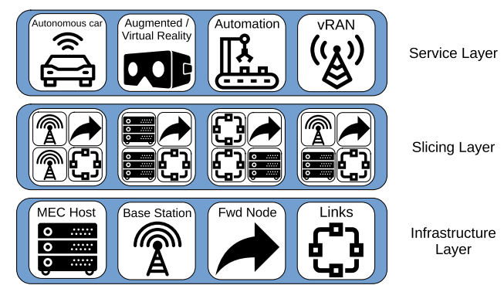

***FIGURE 1. EXP-RAN layers***

eXP-RAN emulation tool allows us to use three different approaches to interacting with the user with the system[14]. The first method is the eXP-RAN tool can be used to perform an analysis of optimization model output. The second-way approach of the system is with the help of a Topology Generator which generates random network topologies on its own with RAN, EC, or as modified by the user by modifying the number of nodes, links, services, and the type of each node. This is beneficial for those users who have minimum knowledge of RAN slicing, slice abstraction, and isolation[29]. The third way of approach allows users to create their own infrastructure and services JSON file. It allows the user with freedom of moderation of describing the infrastructure file and service file by updating JSON files following eXP-RAN modules. This method is most advantageous, allowing the user to interact with the system and its services.The benchmarker module ensures predictable performance by modifying the tool according to the user's hardware. The eXP-RAN emulator comprises of various system modules that are,

*Model Adapter*: This module deals with processing the outcome of the optimization model and converting them into description files for working of eXP-RAN.

*Topology Generator*: It is used to create random RAN network topology. In creating new logical networks, this module takes the help of factors such as a variety of nodes, topology graphs, services, links, etc. And when the network is ready, nodes are classified as per the following ratios forwarding nodes, base stations, MEC host nodes, and in a 65:30:5 ratio[1], respectively. Now the final topology created is given as input into the infrastructure description file, where users can modify by providing their own topologies by mentioning JSON file. This file enables users to modify the contents like number of nodes, links, services, etc.

*Infrastructure Manager*: This module receives the input of the infrastructure description file from the model adapter module or topology generation module or given by users themselves. Thus, creating the nature of system service that emulates the created infrastructure accordingly. There arises the issue of network traffic between two modules and their routing. Thus, the eXP-RAN emulation tool includes controller, which gives freedom to the users to create multiple ways in the network so that it becomes easy to route the network traffic and create restrictions[18]. This network controller allows the users to use network rules that manage the network traffic on each virtual switch and establish a virtual machine inside the containers present.

*Service Manager*: This module runs after infrastructure is created by the infrastructure manager module. This module applies the service-specific configuration required by some services to operate properly.

*System Monitor*: Setting of observation standards in relation to infrastructure description file and service description file are designed by this module[10][15]. The final results of system services are stored in the document and can easily be used for better analysis and research by plotting conclusions graphically.

*Benchmarker Module*: Finally, this module is an important built-in feature in software emulation tools which is a unique module found and is not relatable to any other tools. This module assures the necessary productive prerequisites used in altering the software relative to the hardware constraints of the system where it is running. As a result, this helps the users to decide the method of emulating the service.

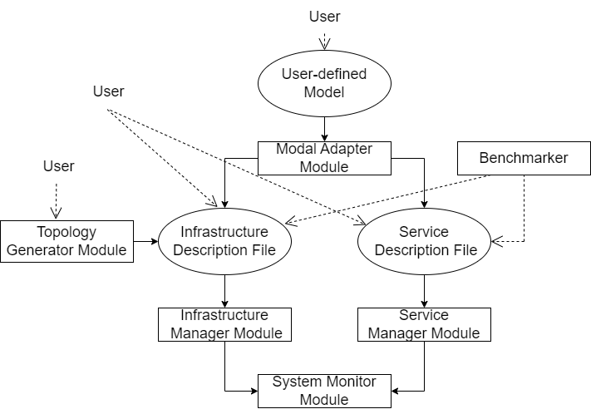

***FIGURE 2. EXP-RAN system modules and workflow process.***

## Implementation Of Network Nodes

This section describes how the MEC host, base station, and forwarding nodes are implemented, which are needed for emulating the network topology.

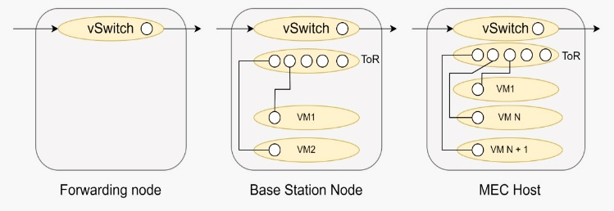

***FIGURE 3. Implementation of Forwarding nodes, Base Station and MEC host***

*Forwarding Node*: They are implemented to initiate the network traffic in a forward manner. In addition to this, they have a controller created by OpenvSwitch(OvS) and modified by using Linux traffic control(LTC) and applying OpenFlow rules. Network traffic between links of a node is restricted, which is emulated by LTC by changing key performance factors of dynamic slicing of network signal. Also, OpenFlow rules are used for specifying the path in order to route the service traffic. Therefore the network traffic can be done by using low computational capacity.

*Base Station Node*: This node consists of virtual machines to showcase the restricted computing capacity and many virtual switches. The initial switch behaves like a packet forwarder, similar to what was discussed above. The next switch establishes a connection between Virtual Machines(VMs) present inside the base station node. Tools such as OvS, LTC, and OpenFlow are also used for packet forwarding, where we use Xen VMs for the representation of the server and the container to depict virtual resources present in the network.

*MEC host*: These nodes are prioritized over other nodes because of their huge computational capability, which includes multiple switches and VMs which work similarly to the base station switches context. MEC hosts are of high computational capacity node which includes the number of VMs and containers. More virtual machines add to the computational capacity of the node, which performs the task of forwarding, managing, and routing the traffic.

## Importance Of Benchmarker Module

The majority of users utilize hardware resources that are insufficient to emulate topologies and networks. Which requires the usage of more than a hundred nodes which in turn requires multiple CPU core systems to perform the process of generating huge throughput, and our system will not be able to sustain these emulation requirements[9]. So this benchmark module was implemented keeping this restriction in consideration which alters the tool such that EXP-RAN consumes only those resources required by the user while performing an emulation. This requires high throughput and minimum packet loss to achieve the requirements.

# emulation and evaluation

### vRAN Emulation

In a virtualized RAN, the functions of cell stations are executed as VNFs, where initialization is based on the functional split, which defines what all VNFs can be operated on a Remote Unit(RU)and the remaining on a Central Unit (CU)[34][35]. VNFs have particular needs for their latency and capacity, therefore it requires proper positioning of the VNFs. The issue with RAN creation is the packet loss generation from the transmitter when throughput exceeds the threshold value. Then packet loss definition becomes negligible in the context of evaluation, like 0.1% considered as the maximum accepted packet loss[1] that is going to be used as input for the benchmarker module. It is smart to select a scale factor lower than benchmarker's recommended value.

Emulation tool eXP-RAN used for testing the model by varying several different parameters. The aim was to minimize the cost of the network operator[25] and simultaneously meet the customer's requirement. Emulation scenarios were constructed using the model adapter for evaluation captioned from A to F where emulations were done in randomly generated topology as shown figure. 4. Blue coloured node represents CU. The green node represent the forwarding nodes and finally the black coloured node are the base stations. There are six vRAN services since there are six base stations as shown in figure. 4.

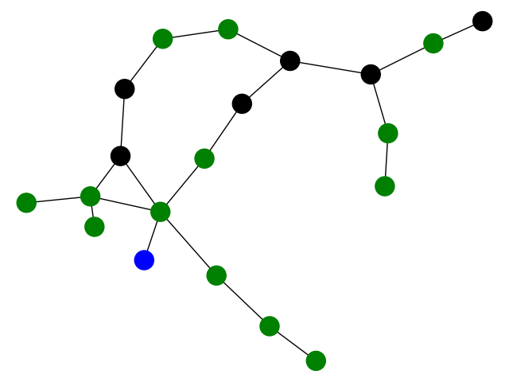

***FIGURE 4. Emulated topology randomly generated***

All scenario emulates the same six vRAN services, along with that scenarios from B to F also emulate one additional MEC service deployed in the CU. In scenario A, there are only six vRAN services that were optimally deployed. This scenario confirmed the expected performance derived from the benchmarker module, i.e., the packet loss was negligible in all vRAN services by applying the proper scale factor[1].

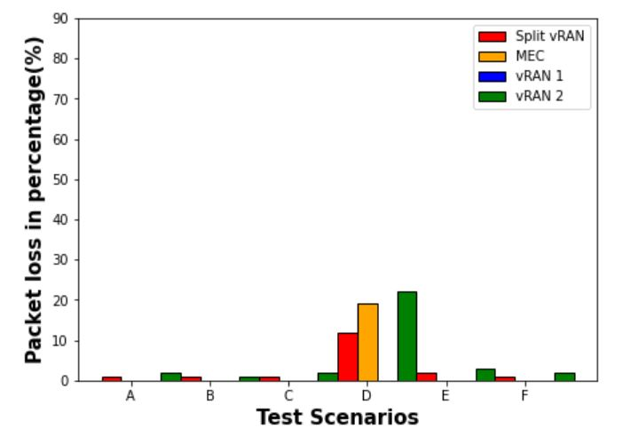

***FIGURE 5. Effect due to MEC service used by 10 users.***

The figure. 5 concludes that vRAN services get affected only in scenario D. The solution for this effect is to use different routes for vRAN services by bringing minor changes in splits based on the function.

The impact on the vRAN service increases as the number of MEC users increases[39]. As services are utilized by 100 users, keeping the same configuration. All cases of emulation are affected by huge packet loss with MEC service, and all the vRAN services suffer from a minimum of one scenario. ‘vRAN 2’ is less affected comparatively, while scenario B and scenario C have the highest packet loss.

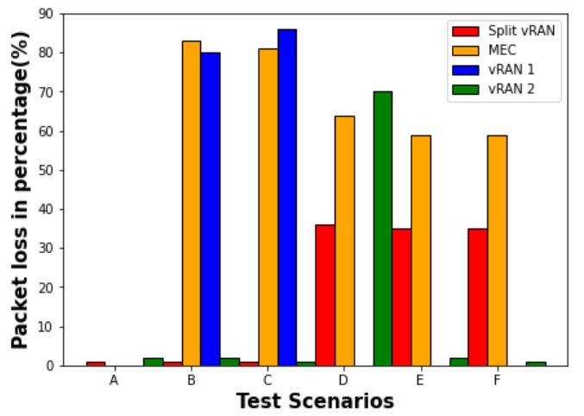

***FIGURE 6. Effect due to MEC services used by 100 users.***

In figure. 6 we tried to analysis the effect of MEC service after an optimal allocation of vRAN services[12].

* 1. *Video Streaming Service Emulation:*

Before 2025, most of the network traffic will be videographic type applications which will be produced from mobile devices. Slicing of the network assures proper network utilization to help by providing virtualized infrastructure to the users and allow users to modify as per their specifications.

Here, we demonstrate that eXP-RAN emulates two slices for different video service providers having different QoS requirements and needs. The topology used for the emulation is shown in figure. 7. We observe how they are related as the load of the work on them varies.

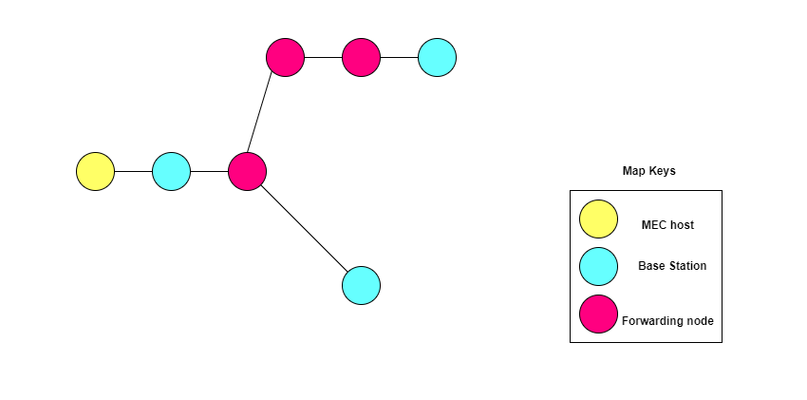

***FIGURE 7. Video streaming services topology.***

Taking two slices into consideration, the first one is slice X which is taken by video service provider A, and the second one is slice Y, allocated to service provider B. Video service provider A offers video services to those users who are ready to be charged more in return for the content having extremely good quality, whereas video service provider B offers the service at a low price, but with a content whose the video quality gets affected due to other load from other users present on the same network. Therefore, video service provider A offers a high definition service to clients, whereas video service provider B provides standard definition service to clients. The assumption is made that both service providers are taking network slices from the common infrastructure.

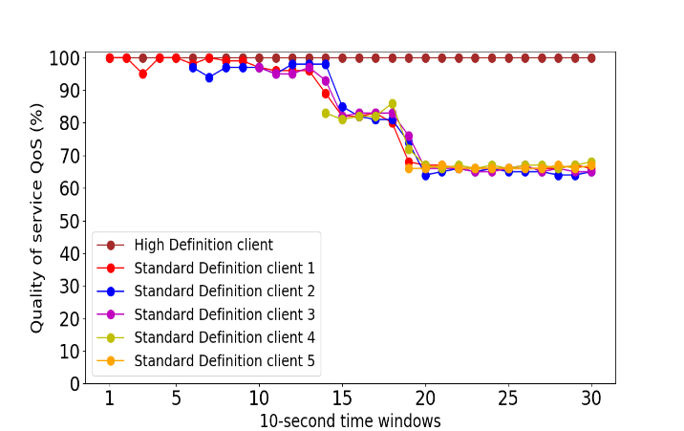

***FIGURE 8. Video streaming services results.***

The result of this experiment is shown in figure. 8. The horizontal axis depicts the time window, where the length of each time window is 10 seconds. The vertical axis depicts the QoS received by each user. High QoS ensures stable performance from the applications having very limited network capacity. Thus allowing organizations to modify their network traffic by prioritizing high-performance applications.

We thus conclude that the QoS of the slices that are provided to the users gets affected due to the workload present on the slices. In this experiment, when workload starts to increase, QoS being given to user belonging to ''High Definition'' remains unchanged, whereas for the user belonging to 'Standard Definition', the QoS starts to decrease, as the workload increases. Therefore, the created slices are able to meet their expected results.

# conclusion

The paper showcases the working eXP-RAN emulator, that can emulate RANs and EC infrastructures. It supports network resource slicing and evaluation of the performance of services that are running in those slices dynamically[16][17]. The paper analyzed the vRAN emulation and video streaming service emulation on two different network slices i.e. high definition client slice and standard definition client slice. There is further scope of work that can be done, such as addition of more use cases, allowing more number of network slices in accordance with 3GPP and enabling combination of network slicing and placement of vRAN network functions[1] over the network, and also improving the existing support for automating the service deployment and the system monitoring[1].

# references

1. Joao Paulo Esper, Abdallah S. Abdallah, Stuart Clayman, Waldir Moreira et al. "EXP-RAN - an Emulator for Gaining Experience with Radio Access Networks, Edge Computing, and Slicing" , IEEE Access, 2020.
2. B. Ojaghi, F. Adelantado, E. Kartsakli, A. Antonopoulos and C. Verikoukis, "Sliced-RAN: Joint Slicing and Functional Split in Future 5G Radio Access Networks," ICC 2019 - 2019 IEEE International Conference on Communications (ICC), 2019, pp. 1-6, doi: 10.1109/ICC.2019.8761081
3. Q. Ye, J. Li, K. Qu, W. Zhuang, X. S. Shen and X. Li, "End-to-End Quality of Service in 5G Networks: Examining the Effectiveness of a Network Slicing Framework," in IEEE Vehicular Technology Magazine, vol. 13, no. 2, pp. 65-74, June 2018, doi: 10.1109/MVT.2018.2809473.
4. J. -J. Chen et al., "Realizing Dynamic Network Slice Resource Management based on SDN networks," 2019 International Conference on Intelligent Computing and its Emerging Applications (ICEA), 2019, pp. 120-125, doi: 10.1109/ICEA.2019.8858288.
5. M. Dalgitsis, J. S. Vardakas and C. Verikoukis, "5G RAN resource slicing with flexible functional splits over multi-tenant environment," 2021 IEEE 26th International Workshop on Computer Aided Modeling and Design of Communication Links and Networks (CAMAD), 2021, pp. 1-6, doi: 10.1109/CAMAD52502.2021.9617786
6. C. M. Mohammed and S. Kheder Shaikhah, "A Survey and Analysis of Architecture and Models of Network Slicing in 5G," 2022 8th International Engineering Conference on Sustainable Technology and Development (IEC), 2022, pp. 192-198, doi: 10.1109/IEC54822.2022.9807564.
7. P. Hegde and S. M. Meena, "A survey on 5G Network Slicing-Epitome and opportunities for a novice," 2021 12th International Conference on Computing Communication and Networking Technologies (ICCCNT), 2021, pp. 1-5, doi: 10.1109/ICCCNT51525.2021.9579745.
8. Icaro da Silva, Gunnar Mildh, Alexandros Kaloxylos, Panagiotis Spapis et al. "Impact of network slicing on 5G Radio Access Networks" , 2016 European Conference on Networks and Communications (EuCNC), 2016
9. Salvatore D'Oro, Francesco Restuccia, Tommaso Melodia. "Toward Operator-toWaveform 5G Radio Access Network Slicing" , IEEE Communications Magazine, 2020
10. Parikshit P Hegde, Shreehari T Alagawadi, Usha S Savadatti, Sahana V Sanagoudar. "To Simulate RAN Slice in 5G Networks" , 2022 IEEE 7th International Conference for Convergence in Technology (I2CT), 2022
11. Sunday O. Oladejo, Olabisi E. Falowo. "Latency-Aware Dynamic Resource Allocation Scheme for Multi-Tier 5G Network: A Network Slicing-Multitenancy Scenario" , IEEE Access, 2020
12. A. A. Abdellatif, A. Mohamed, A. Erbad and M. Guizani, "Dynamic Network Slicing and Resource Allocation for 5G-and-Beyond Networks," 2022 IEEE Wireless Communications and Networking Conference (WCNC), 2022, pp. 262-267, DOI: 10.1109/WCNC51071.2022.9771877.
13. I. da Silva et al., "Impact of network slicing on 5G Radio Access Networks," 2016 European Conference on Networks and Communications (EuCNC), 2016, pp. 153-157, DOI: 10.1109/EuCNC.2016.7561023.
14. C. -Y. Chang, N. Nikaein and T. Spyropoulos, "Radio access network resource slicing for flexible service execution," IEEE INFOCOM 2018 - IEEE Conference on Computer Communications Workshops (INFOCOM WKSHPS), 2018, pp. 668-673, DOI: 10.1109/INFCOMW.2018.8407021.
15. A. Mathew, "Network Slicing in 5G and the Security Concerns," 2020 Fourth International Conference on Computing Methodologies and Communication (ICCMC), 2020, pp. 75-78, DOI: 10.1109/ICCMC48092.2020.ICCMC-00014.
16. H. D. R. Albonda and J. Pérez-Romero, "An Efficient RAN Slicing Strategy for a Heterogeneous Network With eMBB and V2X Services," in IEEE Access, vol. 7, pp. 44771-44782, 2019, DOI: 10.1109/ACCESS.2019.2908306.
17. S. Costanzo, I. Fajjari, N. Aitsaadi and R. Langar, "Dynamic Network Slicing for 5G IoT and eMBB services: A New Design with Prototype and Implementation Results," 2018 3rd Cloudification of the Internet of Things (IoT), 2018, pp. 1-7, DOI: 10.1109/CIOT.2018.8627115.
18. J. -J. Chen et al., "Realizing Dynamic Network Slice Resource Management based on SDN networks," 2019 International Conference on Intelligent Computing and its Emerging Applications (ICEA), 2019, pp. 120-125, DOI: 10.1109/ICEA.2019.8858288.
19. H. Yang et al., "Data-Driven Network Slicing From Core to RAN for 5G Broadcasting Services," in IEEE Transactions on Broadcasting, vol. 67, no. 1, pp. 23-32, March 2021, DOI: 10.1109/TBC.2020.3031742.
20. Y. Tsukamoto, R. K. Saha, S. Nanba and K. Nishimura, "Experimental Evaluation of RAN Slicing Architecture With Flexibly Located Functional Components of Base Station According to Diverse 5G Services," in IEEE Access, vol. 7, pp. 76470-76479, 2019, DOI: 10.1109/ACCESS.2019.2922251.
21. R. Liu, X. Hai, S. Du, L. Zeng, J. Bai and J. Liu, "Application of 5G network slicing technology in smart grid," 2021 IEEE 2nd International Conference on Big Data, Artificial Intelligence and Internet of Things Engineering (ICBAIE), 2021, pp. 740-743, DOI: 10.1109/ICBAIE52039.2021.9389979.
22. M. Nerini and D. Palma, "5G Network Slicing for Wi-Fi Networks," 2021 IFIP/IEEE International Symposium on Integrated Network Management (IM), 2021, pp. 633-637.
23. S. E. Elayoubi, S. B. Jemaa, Z. Altman and A. Galindo-Serrano, "5G RAN Slicing for Verticals: Enablers and Challenges," in IEEE Communications Magazine, vol. 57, no. 1, pp. 28-34, January 2019, DOI: 10.1109/MCOM.2018.1701319.
24. C. -Y. Chang, N. Nikaein and T. Spyropoulos, "Radio access network resource slicing for flexible service execution," IEEE INFOCOM 2018 - IEEE Conference on Computer Communications Workshops (INFOCOM WKSHPS), 2018, pp. 668-673, DOI: 10.1109/INFCOMW.2018.8407021.
25. W. -P. Lai, M. -J. Lai and H. -L. Lai, "A Semi-Empirical Data-Rate Estimation Method of 5G RAN Slicing," 2021 Asia-Pacific Signal and Information Processing Association Annual Summit and Conference (APSIPA ASC), 2021, pp. 1935-1941.
26. I. Vilà, J. Pérez-Romero, O. Sallent and A. Umbert, "Characterization of Radio Access Network Slicing Scenarios With 5G QoS Provisioning," in IEEE Access, vol. 8, pp. 51414-51430, 2020, doi: 10.1109/ACCESS.2020.2980685.
27. H. D. R. Albonda and J. Pérez-Romero, "An Efficient RAN Slicing Strategy for a Heterogeneous Network With eMBB and V2X Services," in IEEE Access, vol. 7, pp. 44771-44782, 2019, doi: 10.1109/ACCESS.2019.2908306.
28. J. Mei, X. Wang and K. Zheng, "An intelligent self-sustained RAN slicing framework for diverse service provisioning in 5G-beyond and 6G networks," in Intelligent and Converged Networks, vol. 1, no. 3, pp. 281-294, Dec. 2020, doi: 10.23919/ICN.2020.0019.
29. R. Liu, X. Hai, S. Du, L. Zeng, J. Bai and J. Liu, "Application of 5G network slicing technology in smart grid," 2021 IEEE 2nd International Conference on Big Data, Artificial Intelligence and Internet of Things Engineering (ICBAIE), 2021, pp. 740-743, doi: 10.1109/ICBAIE52039.2021.9389979.
30. H. Yang et al., "Data-Driven Network Slicing From Core to RAN for 5G Broadcasting Services," in IEEE Transactions on Broadcasting, vol. 67, no. 1, pp. 23-32, March 2021, doi: 10.1109/TBC.2020.3031742.
31. S. Costanzo, I. Fajjari, N. Aitsaadi and R. Langar, "Dynamic Network Slicing for 5G IoT and eMBB services: A New Design with Prototype and Implementation Results," 2018 3rd Cloudification of the Internet of Things (CIoT), 2018, pp. 1-7, doi: 10.1109/CIOT.2018.8627115.
32. Y. Tsukamoto, R. K. Saha, S. Nanba and K. Nishimura, "Experimental Evaluation of RAN Slicing Architecture With Flexibly Located Functional Components of Base Station According to Diverse 5G Services," in IEEE Access, vol. 7, pp. 76470-76479, 2019, doi: 10.1109/ACCESS.2019.2922251.
33. D. Marabissi and R. Fantacci, "Highly Flexible RAN Slicing Approach to Manage Isolation, Priority, Efficiency," in IEEE Access, vol. 7, pp. 97130-97142, 2019, doi: 10.1109/ACCESS.2019.2929732.
34. H. Yu, F. Musumeci, J. Zhang, M. Tornatore and Y. Ji, "Isolation-Aware 5G RAN Slice Mapping Over WDM Metro-Aggregation Networks," in Journal of Lightwave Technology, vol. 38, no. 6, pp. 1125-1137, 15 March15, 2020, doi: 10.1109/JLT.2020.2973311.
35. J. García-Morales, M. C. Lucas-Estañ and J. Gozalvez, "Latency-Sensitive 5G RAN Slicing for Industry 4.0," in IEEE Access, vol. 7, pp. 143139-143159, 2019, doi: 10.1109/ACCESS.2019.2944719.
36. M. A. Habibi, F. Z. Yousaf and H. D. Schotten, "Mapping the VNFs and VLs of a RAN Slice Onto Intelligent PoPs in Beyond 5G Mobile Networks," in IEEE Open Journal of the Communications Society, vol. 3, pp. 670-704, 2022, doi: 10.1109/OJCOMS.2022.3165000.
37. C. -Y. Chang and N. Nikaein, "RAN Runtime Slicing System for Flexible and Dynamic Service Execution Environment," in IEEE Access, vol. 6, pp. 34018-34042, 2018, doi: 10.1109/ACCESS.2018.2847610.
38. Sungwook Kim. "chapter 2 Cloud-Based IoT System Control Problems" , IGI Global, 2017
39. Salman A. AlQahtani, Waseem A. Alhomiqani. "A multi-stage analysis of network slicing architecture for 5G mobile networks" , Telecommunication Systems, 2019